Tutorial 7 – BVA & Equivalence Partitioning
Screenshot Report
Field | Details
Website / Tool | Selenium Web Form
URL | https://www.selenium.dev/selenium/web/web-form.html
Module | Age validation (18 to 60)
Student Task | Apply BVA and EP for the requirement 'Age must be between 18 and 60' using the Text input field as the age field.
Test Cases | Same TC IDs as the test case sheet: BVA01 to EP03
Tester Name | Tester: Kothari Mann Jitendrakumar
Enrollment No | 2504030100433
Environment | Windows 10/11, Google Chrome (latest), internet connection

Note: The Selenium web form has no real age validation, so values such as 17 or 61 may be ACCEPTED. Record exactly what you see: if an invalid value is accepted, mark the test Fail and report it as a defect. If you prefer a site that really validates age, the instructions allow any other demo website.

Test Case Execution

BVA01 – Verify age 17 (invalid boundary value)
TC ID | BVA01
Test Case | Verify age 17 (invalid boundary value)
Test Data | Age: 17
Expected Result | Invalid - value rejected / error shown
Actual Result | The invalid input alert didnt show and age field doesnt exits
Status | Fail
Screenshot | 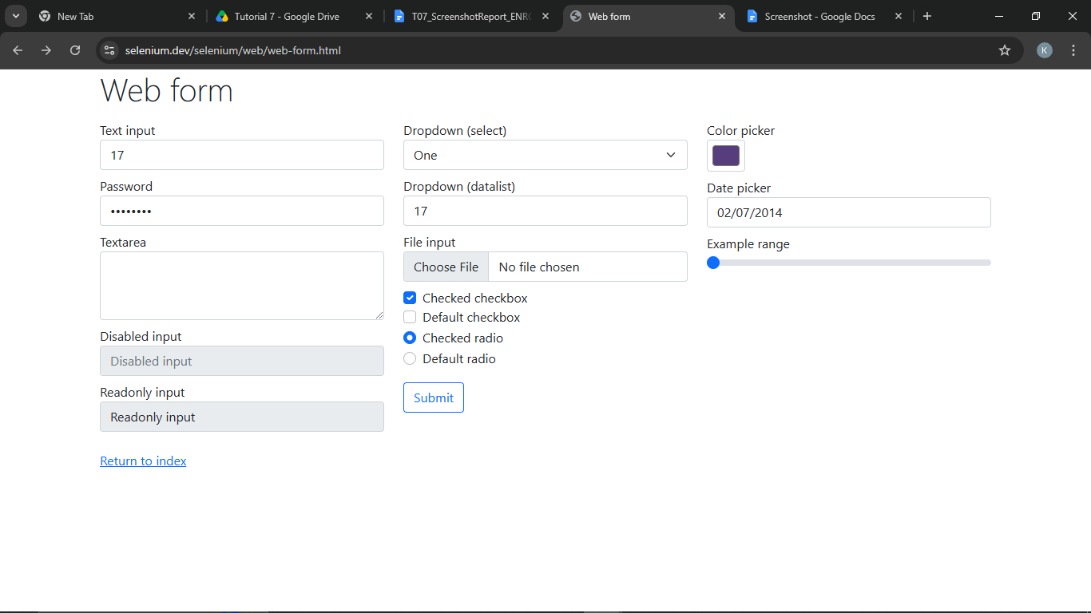
Defect ID | N/A

BVA02 – Verify age 18 (valid boundary value)
TC ID | BVA02
Test Case | Verify age 18 (valid boundary value)
Test Data | Age: 18
Expected Result | Valid - value accepted
Actual Result | The invalid input alert didnt show and age field doesnt exits
Status | Fail
Screenshot | 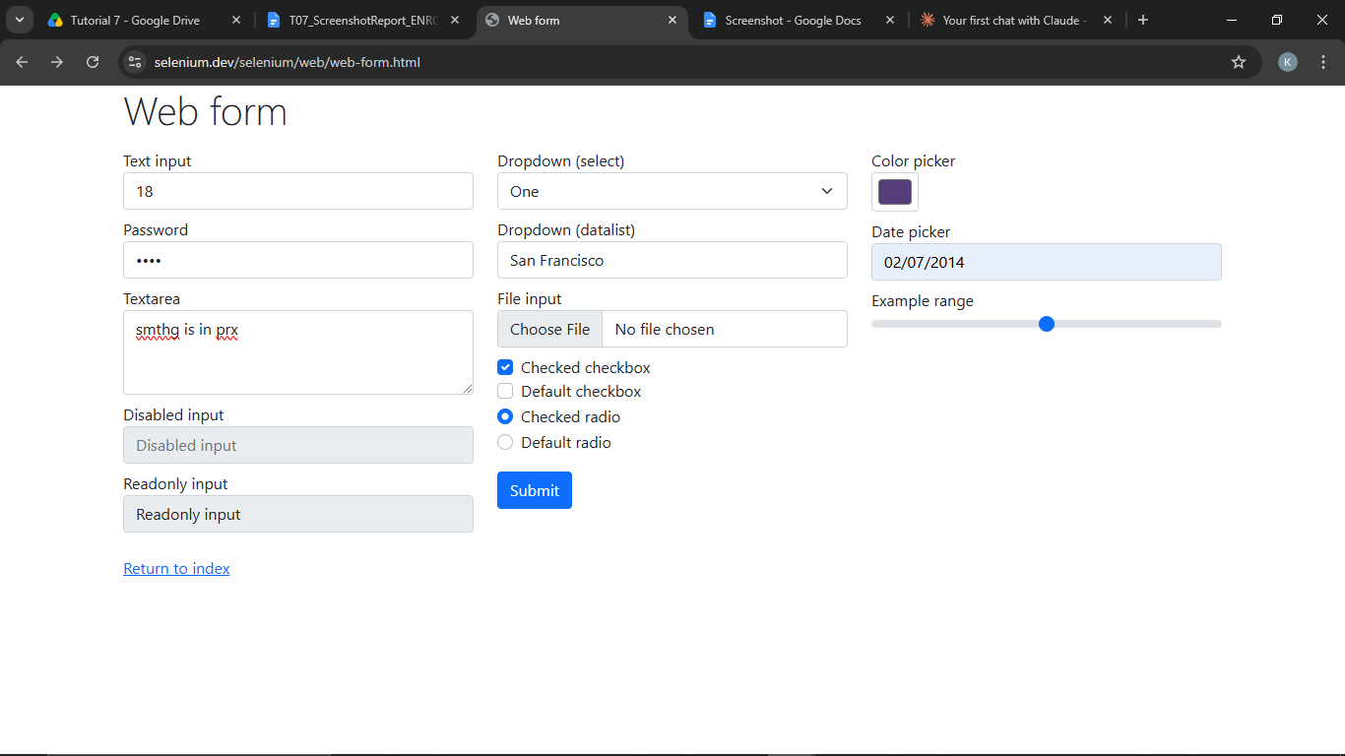
Defect ID | N/A

BVA03 – Verify age 19 (valid boundary value)
TC ID | BVA03
Test Case | Verify age 19 (valid boundary value)
Test Data | Age: 19
Expected Result | Valid - value accepted
Actual Result | The invalid input alert didnt show and age field doesnt exits
Status | Fail
Screenshot | 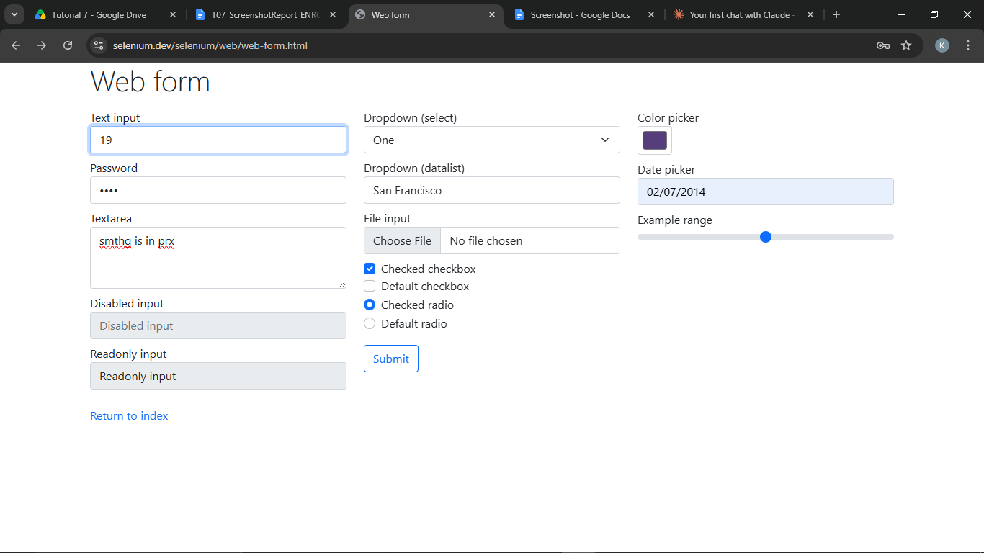
Defect ID | N/A

BVA04 – Verify age 59 (valid boundary value)
TC ID | BVA04
Test Case | Verify age 59 (valid boundary value)
Test Data | Age: 59
Expected Result | Valid - value accepted
Actual Result | The invalid input alert didnt show and age field doesnt exits
Status | Fail
Screenshot | 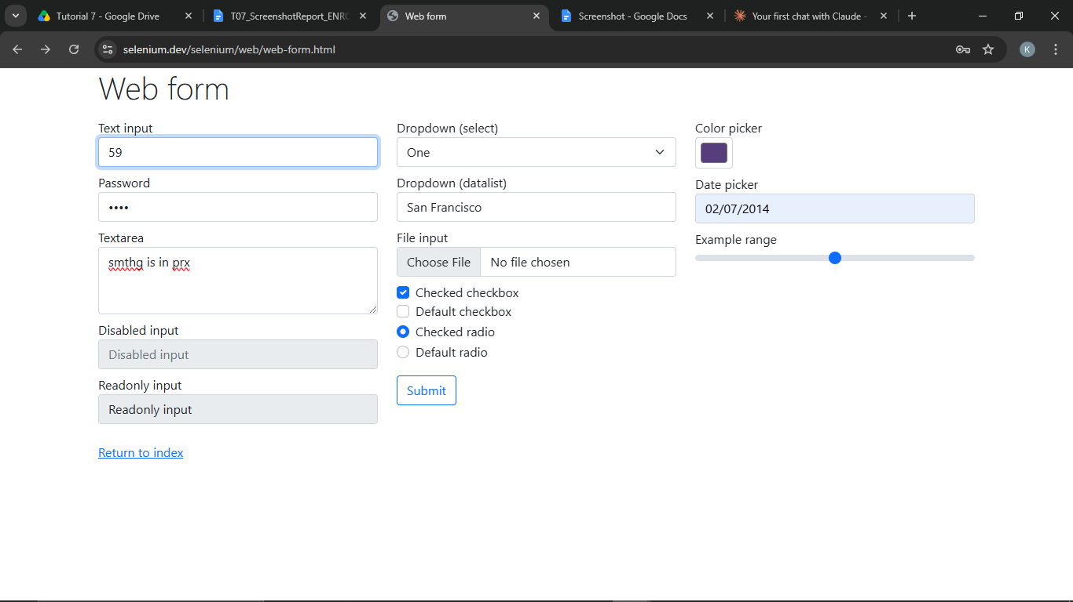
Defect ID | N/A

BVA05 – Verify age 60 (valid boundary value)
TC ID | BVA05
Test Case | Verify age 60 (valid boundary value)
Test Data | Age: 60
Expected Result | Valid - value accepted
Actual Result | The invalid input alert didnt show and age field doesnt exits
Status | Fail
Screenshot | 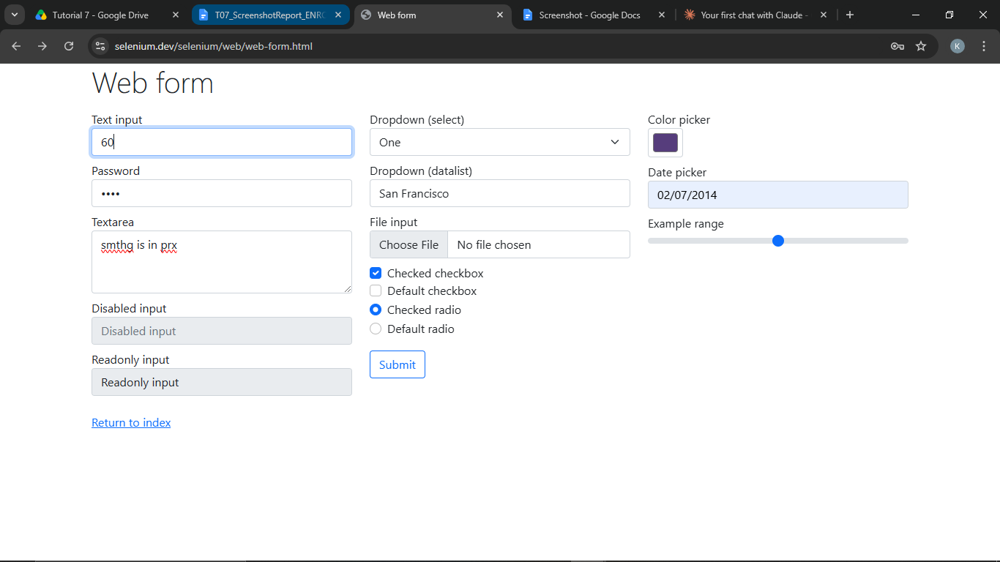
Defect ID | N/A

BVA06 – Verify age 61 (invalid boundary value)
TC ID | BVA06
Test Case | Verify age 61 (invalid boundary value)
Test Data | Age: 61
Expected Result | Invalid - value rejected / error shown
Actual Result | The invalid input alert didnt show and age field doesnt exits
Status | Fail
Screenshot | 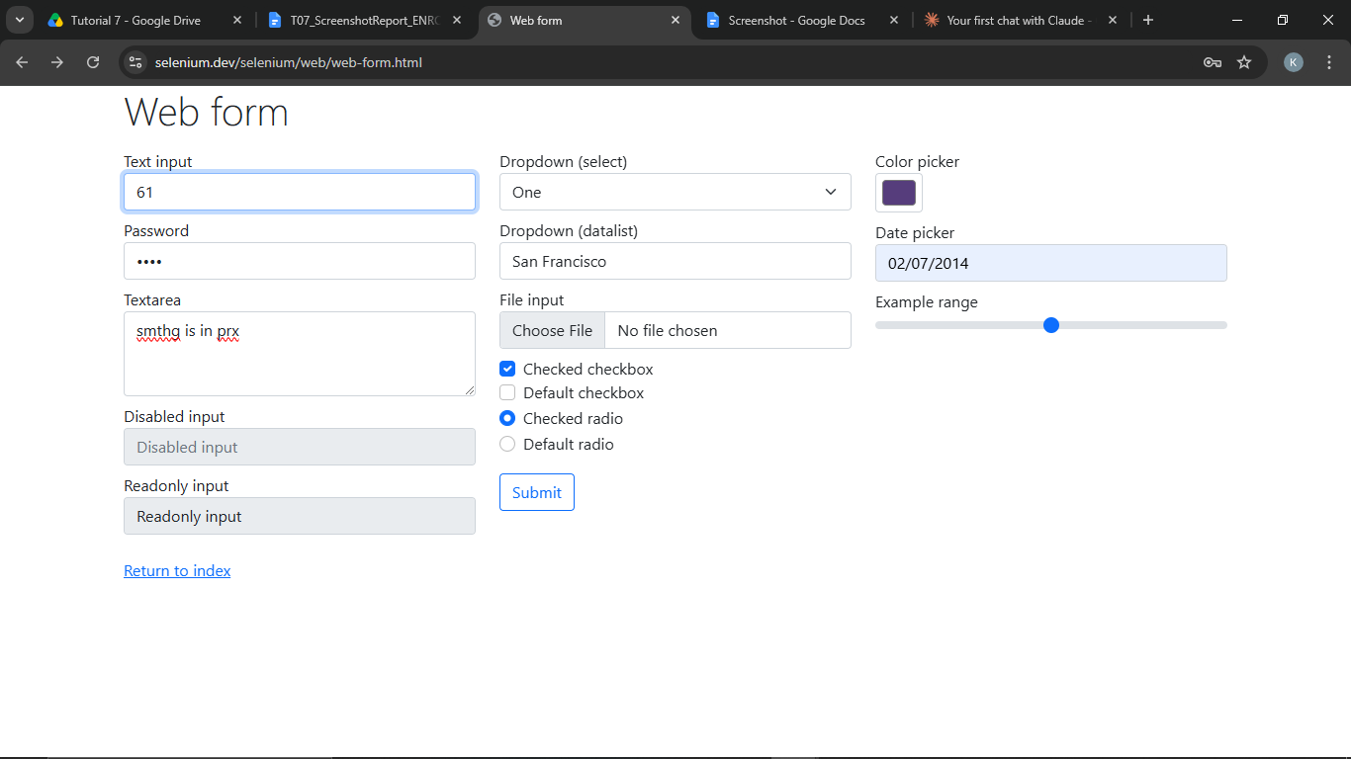
Defect ID | N/A

EP01 – Verify age 15 (below 18)
TC ID | EP01
Test Case | Verify age 15 (below 18)
Test Data | Age: 15
Expected Result | Invalid - value rejected / error shown
Actual Result | The invalid input alert didnt show and age field doesnt exits
Status | Fail
Screenshot | 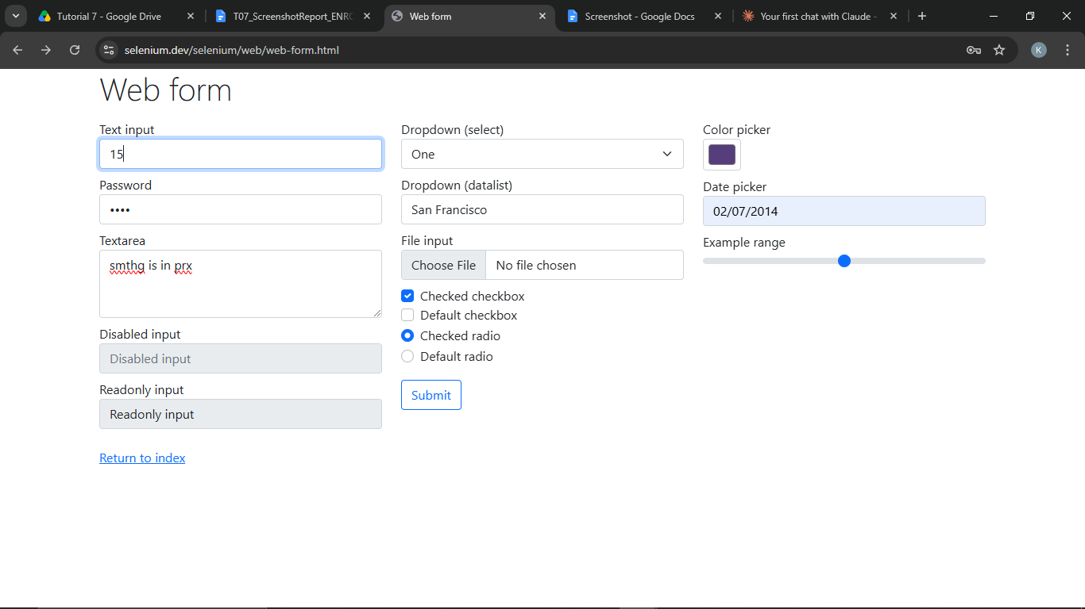
Defect ID | N/A

EP02 – Verify age 30 (within 18-60)
TC ID | EP02
Test Case | Verify age 30 (within 18-60)
Test Data | Age: 30
Expected Result | Valid - value accepted
Actual Result | The invalid input alert didnt show and age field doesnt exits
Status | Fail
Screenshot | 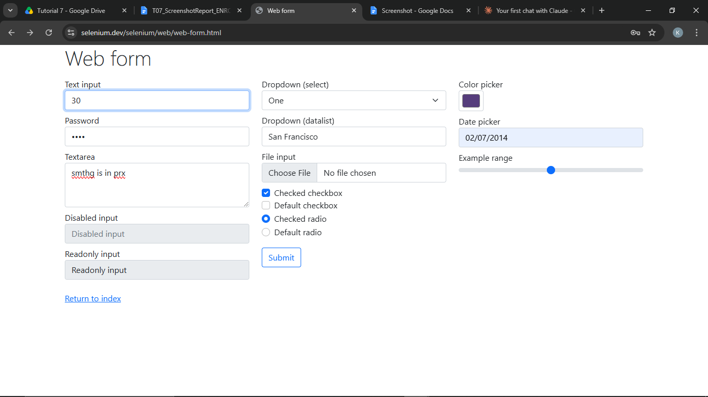
Defect ID | N/A

EP03 – Verify age 65 (above 60)
TC ID | EP03
Test Case | Verify age 65 (above 60)
Test Data | Age: 65
Expected Result | Invalid - value rejected / error shown
Actual Result | The invalid input alert didnt show and age field doesnt exits
Status | Fail
Screenshot | 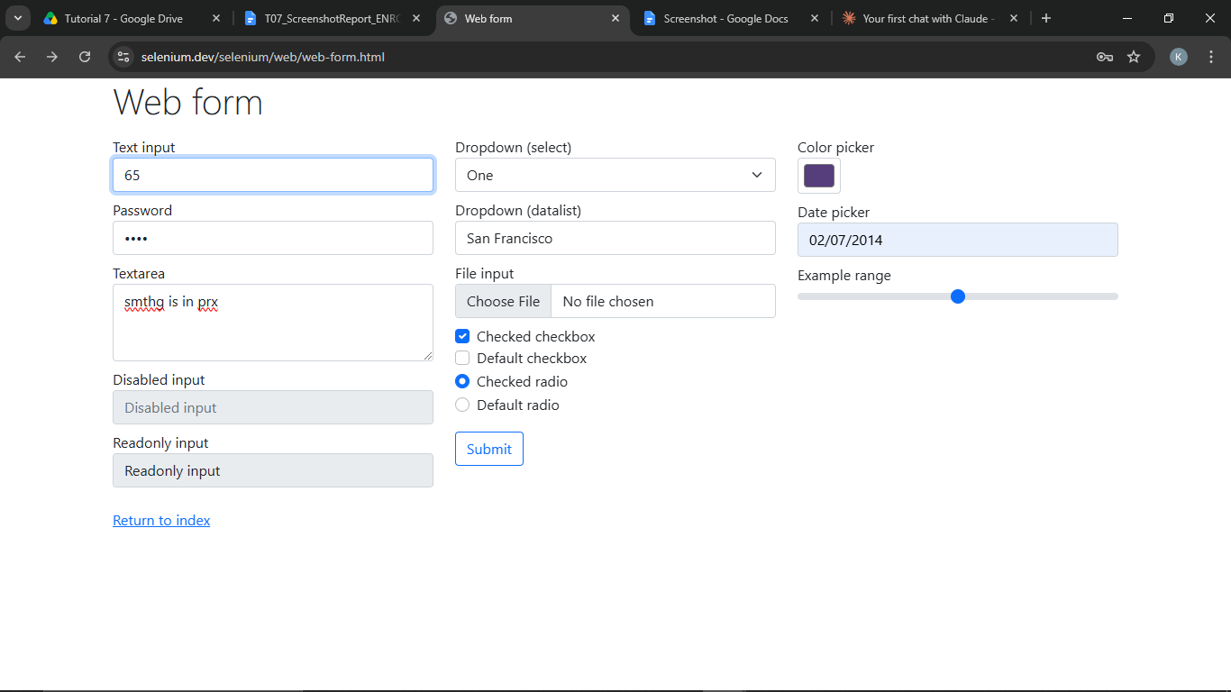
Defect ID | N/A

Equivalence Class Table
Input Field | Input Range / Condition | Equivalence Class Type | Test Value | Expected Result
Age | Below 18 | Invalid | 15 | Invalid
Age | 18 to 60 | Valid | 30 | InValid
Age | Above 60 | Invalid | 65 | Invalid

Boundary Value Analysis (BVA) Table
Input Field | Minimum Value | Just Above Minimum | Nominal Value | Just Below Maximum | Maximum Value | Just Above Maximum
Age | 18 | 19 | 30 | 59 | 60 | 61

Test Execution Summary
Metric | Value
Total Test Cases | 9
Passed | 0
Failed | 0
Blocked | 0
Not executed yet (fill after running) | 9
Pass % | 0.0%

